CURRICULUM VITAE
RANA ABOU CHAKRA

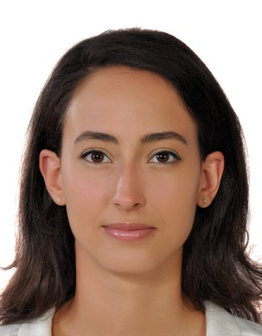
Date of birth: 24/01/1990
Nationality: Lebanese
E-mail address: abouchacra.rana@gmail.com
Italian phone number: 0039 324 629 9306
Professional domicile: Rome- Italy

Objective: Freelance Interpretation. AIIC member since 2020.

Experience*: September 2017 – to date:
Freelance Interpreter/Translator based in Rome mainly working for UN Agencies (FAO, WFP, IFAD and ILO) as well as other entities such as the Italian parliament, the private sector and other entities.

September 2013 - September 2017:
Arabic Translator / Interpreter for the Food and Agriculture Organization of the United Nations (P2 level). Focal point for CAT tools and for implementing Akoma-Ntoso language in the Arabic Translation group. Arabic Group evaluator for CAT-Tool tender.

August 2012 - August 2013:
Translator and voice recorder at Omnisport, powered by Perform Group London. The job consisted of translating and voice-recording articles related to major sports events for news channels in the Arab world.

2010 until 2013:
Freelance translation (documentary TV series of around 30 hours, websites, articles, transcripts, and local events).

March 2013: Note taker at the Arab Spring conference Held by the Lebanese Army for Lebanese officials and international diplomats.

August 2010: Training at the documentation center of the Ministry of Foreign Affairs in Lebanon.

2007- 2012: Private lessons in literature and philosophy to high school students in preparation for the French baccalaureate.

Education: - 2013: Master’s degree in Interpretation at the Saint-Joseph University of Beirut (USJ)
- 2011: Bachelor degree in Modern Languages, specialization in translation at the Saint-Joseph University of Beirut (USJ)
- 2008: French baccalaureate (Mention Bien). Literary section (at the Collège Protestant Français de Beyrouth)

Languages: A language: Arabic
B language: French
C language: English, Spanish, Italian

Qualities: Responsible, interactive, work well under pressure, love to work in a multicultural environment.

Skills: Good use of computer-assisted translation tools for translation and alignment (such as TRADOS, Multitrans, XTM, YouAlign).
Good use of Microsoft programs (especially Word and PowerPoint).

Interests: - Reading: interest in politics, history and economy
- Cultural travelling
- Volunteer at Baobab association for welcoming migrants and refugees; and Energia per I Diritti Umani, an Italian NGO operating Development projects in Senegal, Gambia and India.
- Sports: volleyball, swimming

*References will be furnished upon request.

