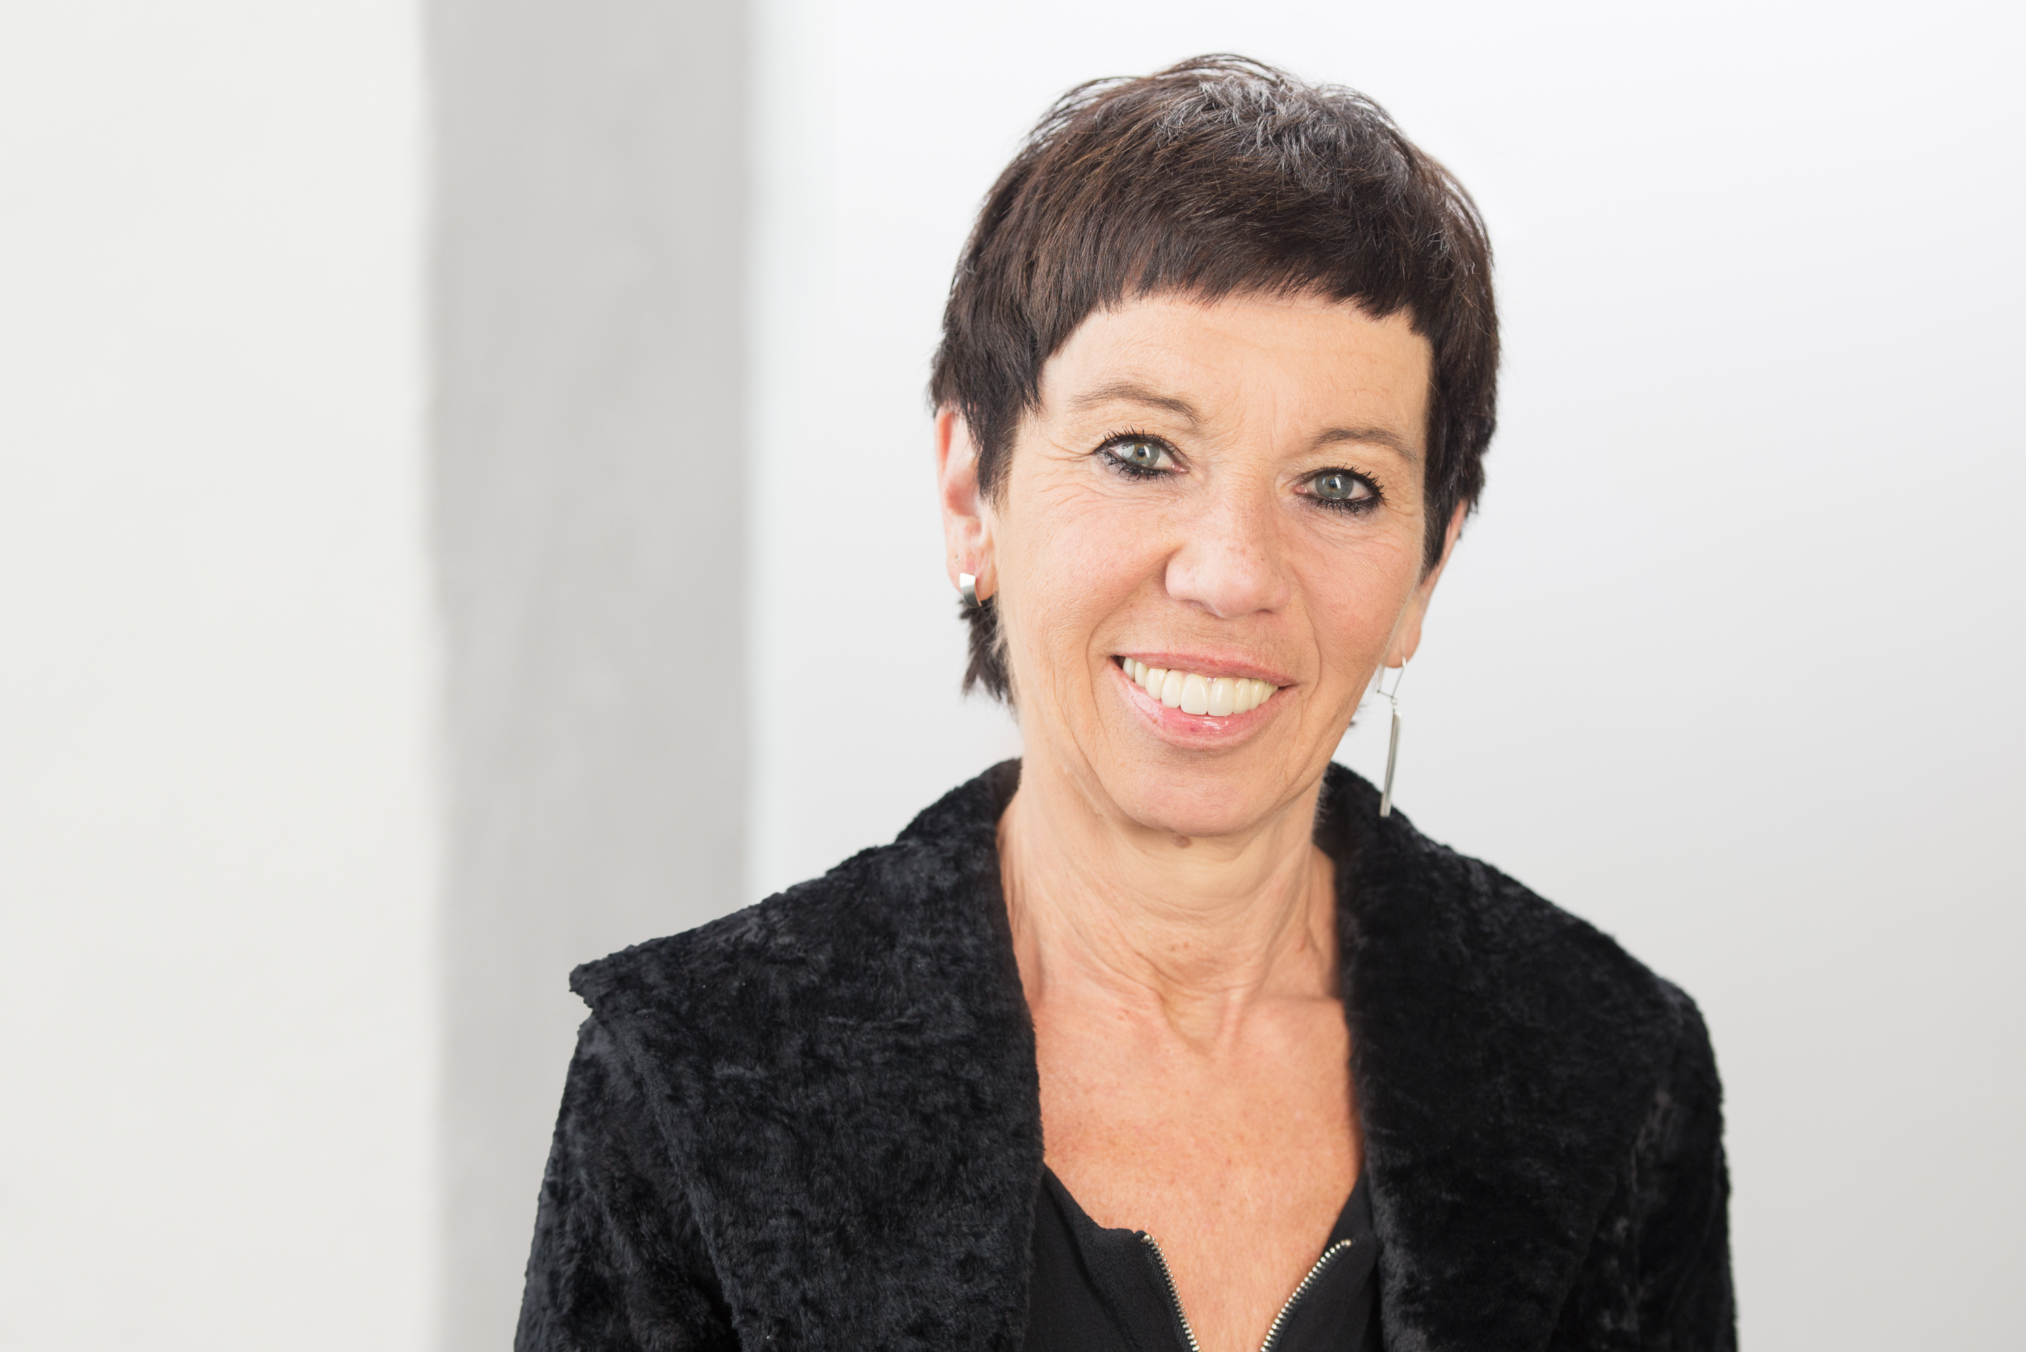

Lilian-Astrid Geese
Motzstr. 62
D-10777 Berlin
Germany

CV

Date of Birth | 3 July 1958
Place of Birth | Bonn, Germany
Education | Helmholtz-Gymnasium, Bonn, Abitur 1976  University of Mainz, FASK Applied Linguistics, Translation and Cultural Studies, English, French + Spanish, Diploma 1979
Residence | Berlin (since 1979)
Career | Free-lance conference interpreter + translator since 1979  Consultant Interpreter: House of World Cultures (HKW) Berlin (since 1990), international literature festival berlin (2000-2018), International Women’s Film Festival Dortmund/Cologne (since 2015), Lesen ohne Atomstrom Hamburg (since 2013)
Languages | A: German  B: English  C: Spanish, French
Memberships | AIIC, VKD BDÜ
Contact details | Mobile: +49.172.2357177  eMail: liageese@comunicada.de
Website | www.comunicada.de
Professional activities | see references on my website www.comunicada.de  and special fields below
Special fields | Politics / IT / Arts, Literature, Film, Theater + Music / Architecture / Social Sciences / Cultural studies / Ecology

